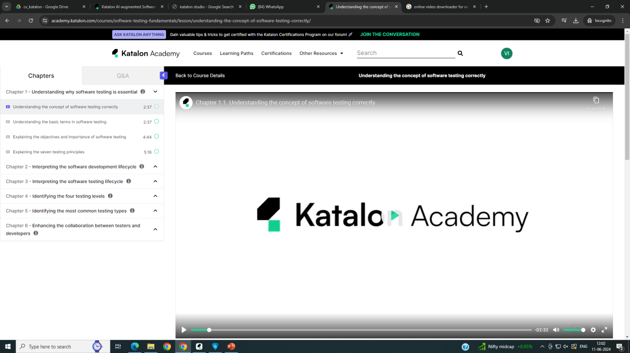

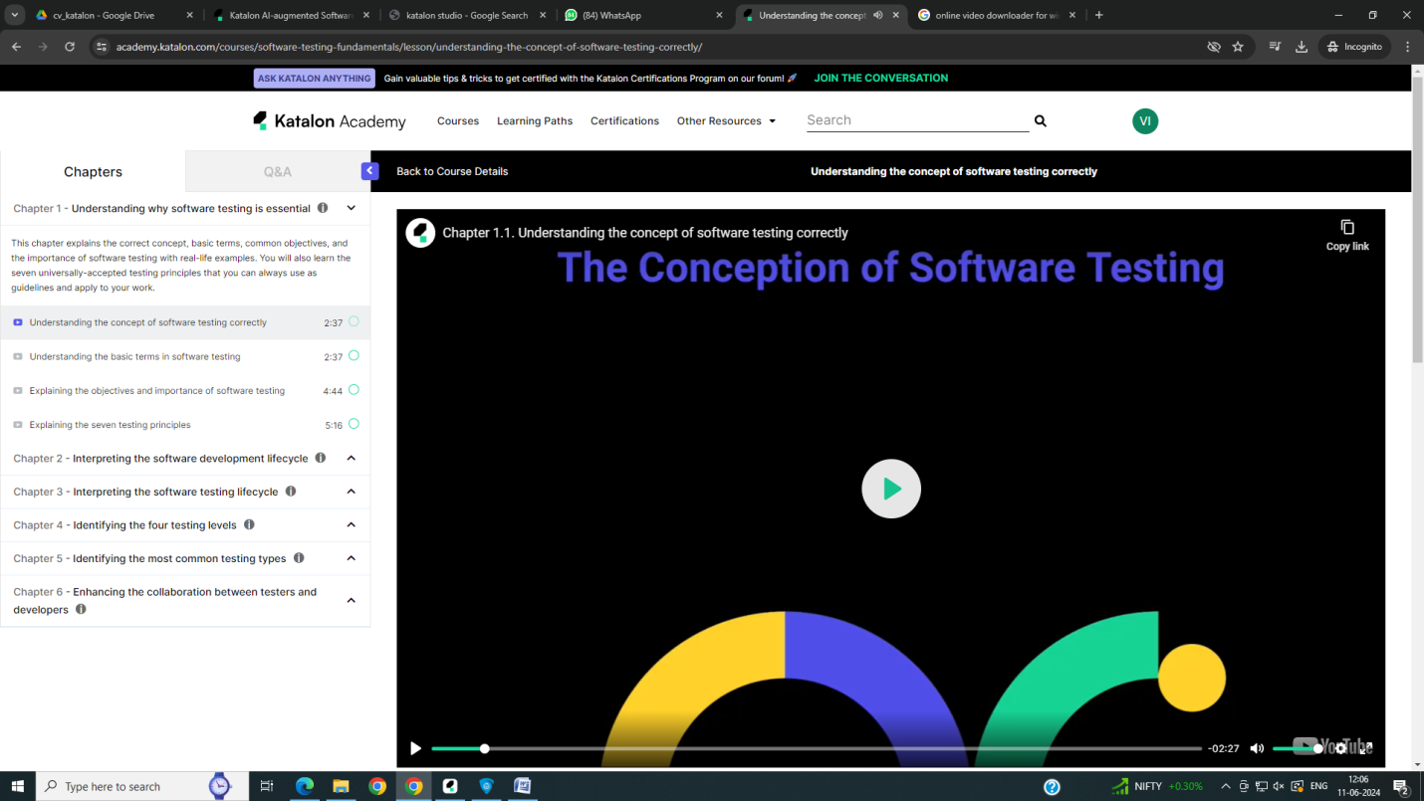

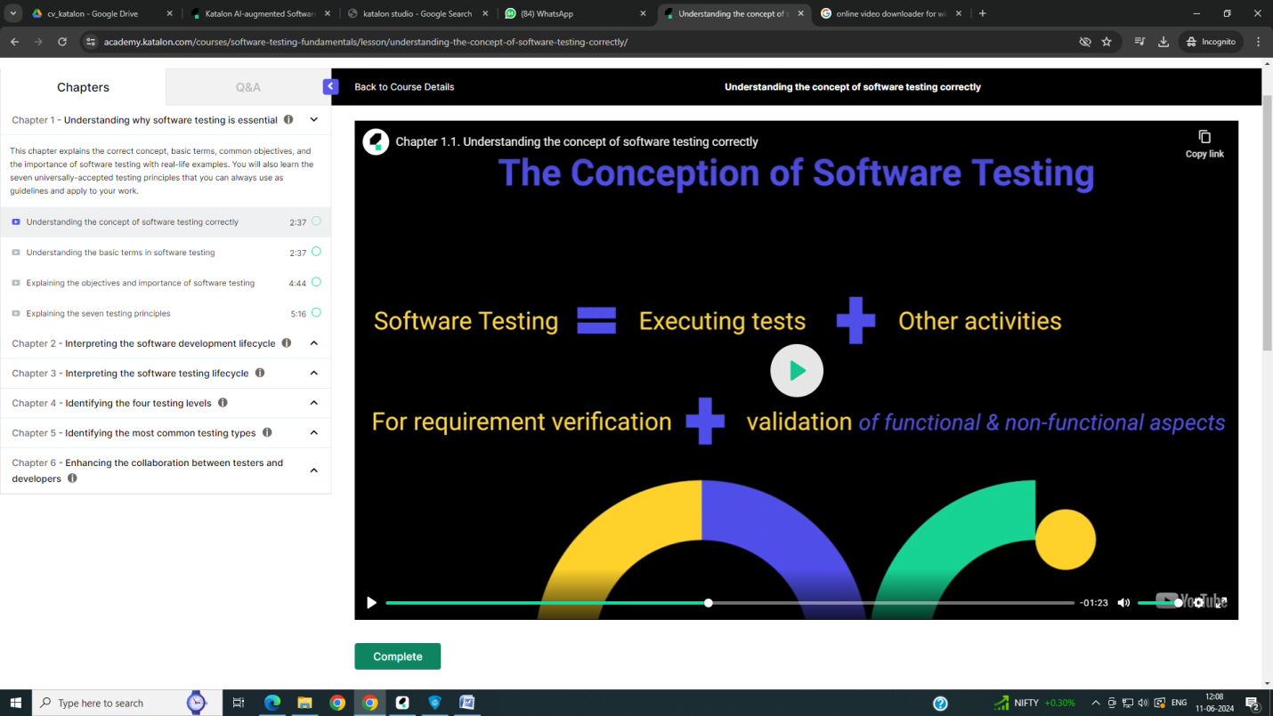

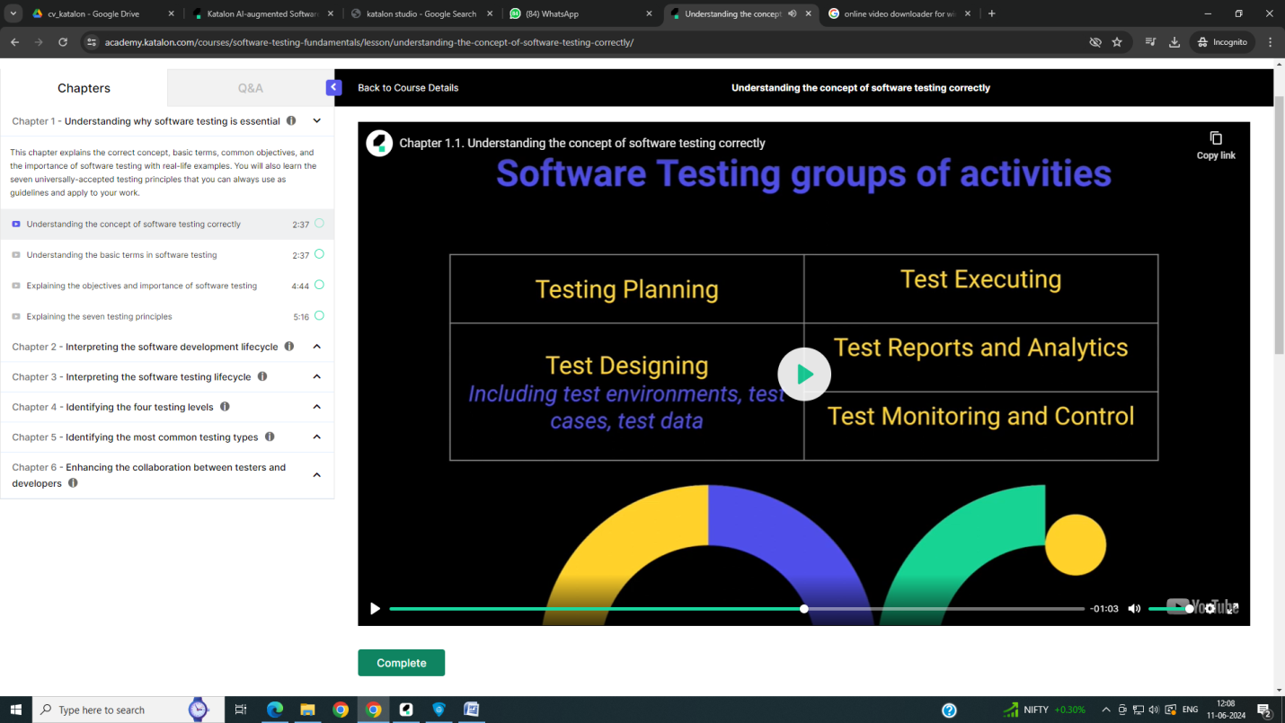

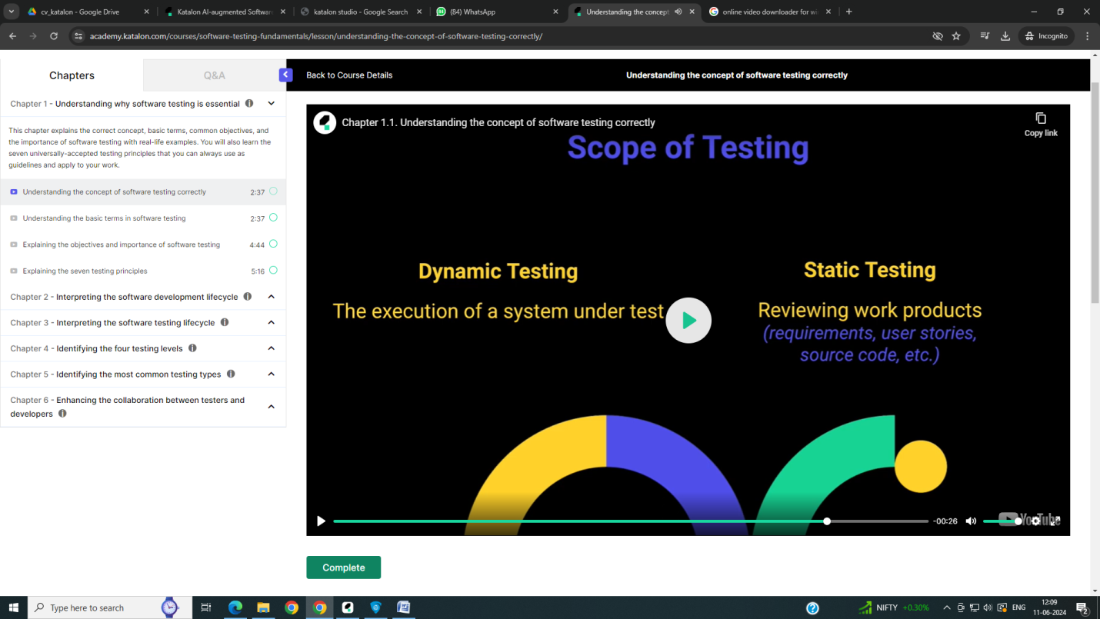

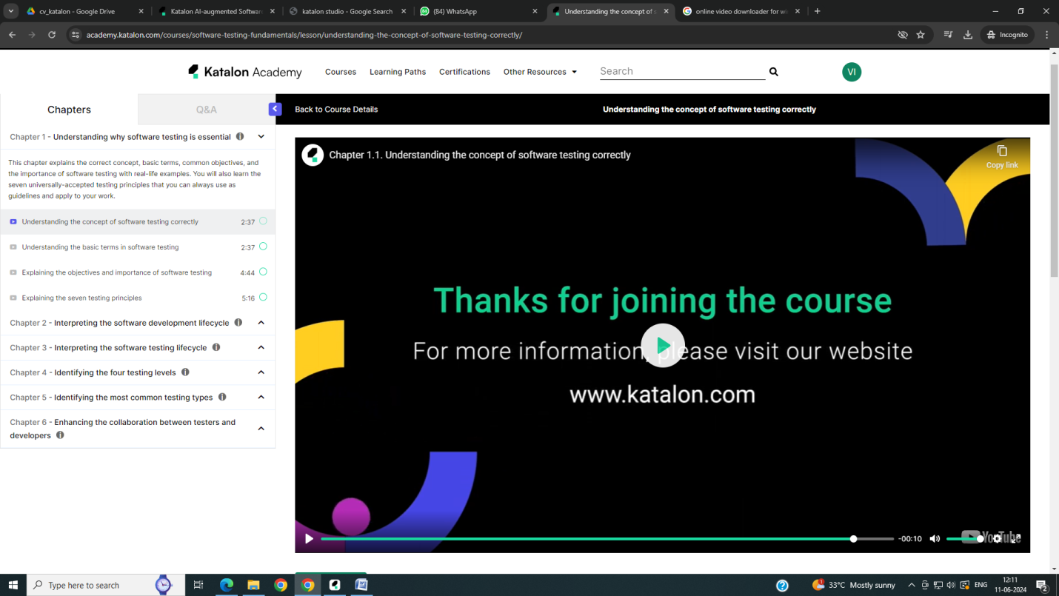

Before moving to the next chapters, it would be helpful for us to learn several basic terms and truly understand what they mean.

The most common terms you will see and hear a lot are Error, Defect, and Failure. They are not the same but closely related.

Their relationship can be described like this: a person makes an error (or mistake) that can introduce a defect (often called bugs, or sometimes called fault) in the software code, which can then lead to a failure of the software during operation. One thing to remember here is that failures of a system are not solely due to defects. They can also result from other environmental factors.

For instance, when writing requirements, a business analyst makes a mistake by misunderstanding a requirement from clients, which leads to a requirement defect. This defect then results in another programming error from an engineer, which leads to a defect in the system code. When the code is later executed, a system failure may trigger during the operation, depending on specific data input.

The next terms we will discuss are Quality management, Quality assurance, and Quality control.

Quality management is the highest level. It includes all activities that direct and control an organization regarding quality, including both quality assurance and quality control.

Quality assurance is more process-oriented. It creates proper processes and makes sure that all team members follow them. When processes are carried out properly, the created work products generally have higher quality. It's reasonable to say that quality assurance focuses more on defect prevention.

Quality control, on the other hand, is more product-oriented. It includes all testing activities to identify defects and achieve different levels of quality. While quality assurance supports proper testing, quality control ensures the proper execution of the entire test process.

In reality, most people and many companies use these two terms interchangeably in work and hiring. When looking for a job, you should pay more attention to the job description, what they require you to do, to know what you're applying for.

Lastly, we will look into the two terms Verification and Validation. Each activity has a completely different purpose.

Verification answers the question ''Do we build the system or product right?'' It ensures a module, system, or product is designed and developed correctly according to the written specifications or requirements.

Validation, on the other hand, answers the question ''Do we build the right system or product?'' It is checking how well the system or product addresses and meets the user's needs and expectations in a real-world context.